New to Diablo Mountain Research - Safety and Hi-Pot Testing Services for Medical Devices
Diablo Mountain Research has added IEC 60601 electrical Safety testing capabilities. With the Fluke ESA612 Safety Analyzer and the Chroma 19073 Hi-Pot Tester Setup.

electrical SafetY IEC60601 standard SafetY Tests called out in the IEC60601 standard

Ground wire (Protective Earth Resistance)

Earth Leakage Current

Touch or Enclosure Leakage Current

Patient Leakage Current

Patient Auxiliary Leakage Current
Mains on Applied Part (MAP) Leakage Current

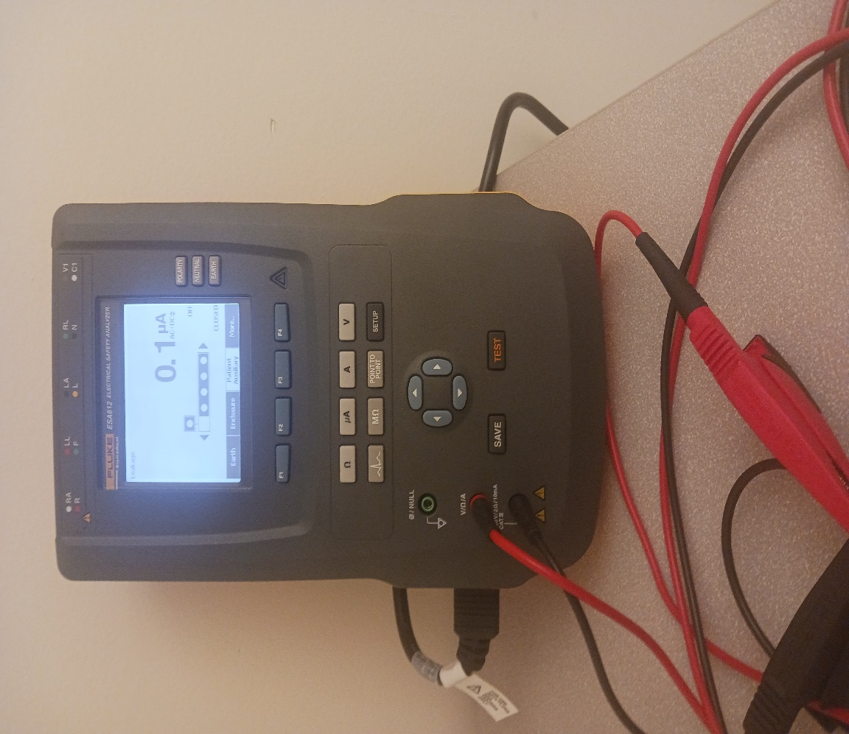
Fluke ESA612 Safety Analyzer.

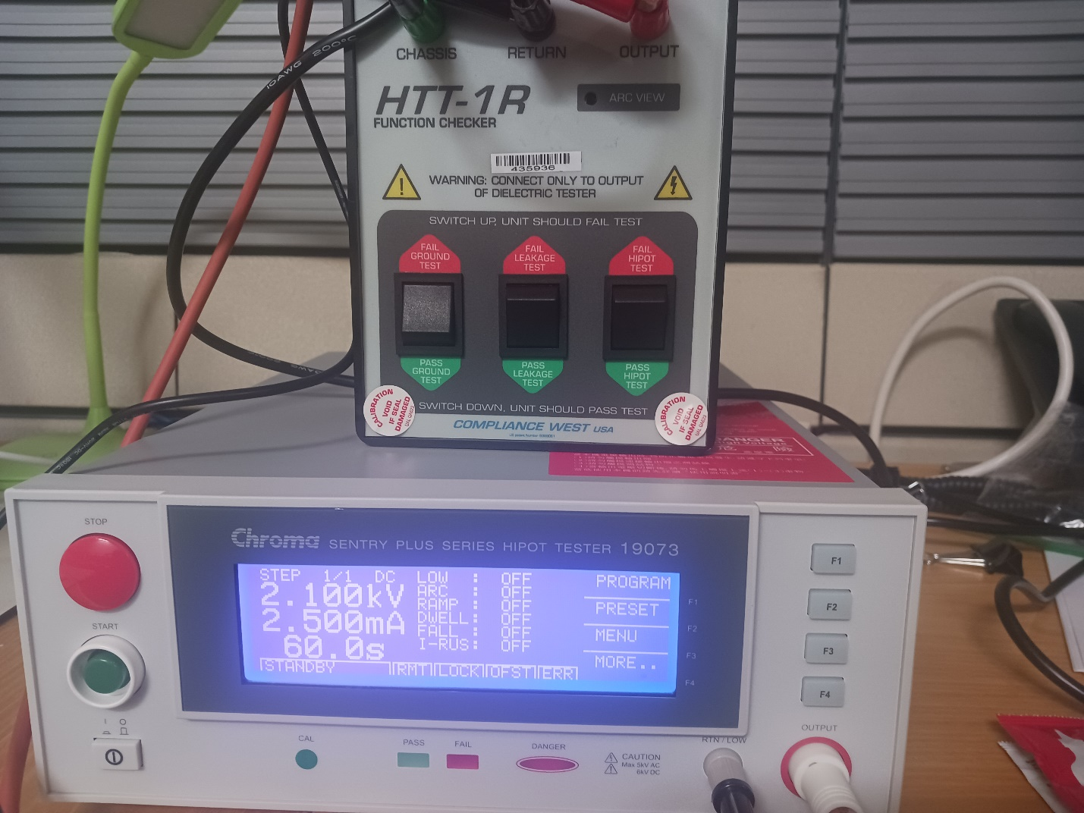

Chroma 19073 Hi-pot tester with httr-1r hi pot teseter verification tool.

Example test configurations.
Ground Wire (Protective Earth) Resistance Test with the ESA 612 Safety Analyzer.

Hi-Pot Test configuration for a Medical Grade Power Supply.
